WEEK 1:Draw the Path: Portfolio Sitemap + Toolkit
- Sketch a portfolio sitemap, the few pages it takes to walk your one person from landing to believing you to the one action (usually: a hero that states the claim, a work/case-studies section, a short about, a contact), and nothing more. Resist adding pages “just because.”

- Set up your free toolkit: accounts for Claude, ChatGPT, Gemini, and Perplexity.

- Create one Claude Project named for this build, with custom instructions (your proof statement pasted in) and a request to act as a tutor. It follows you for all eight weeks.

PROOF STATEMENT:
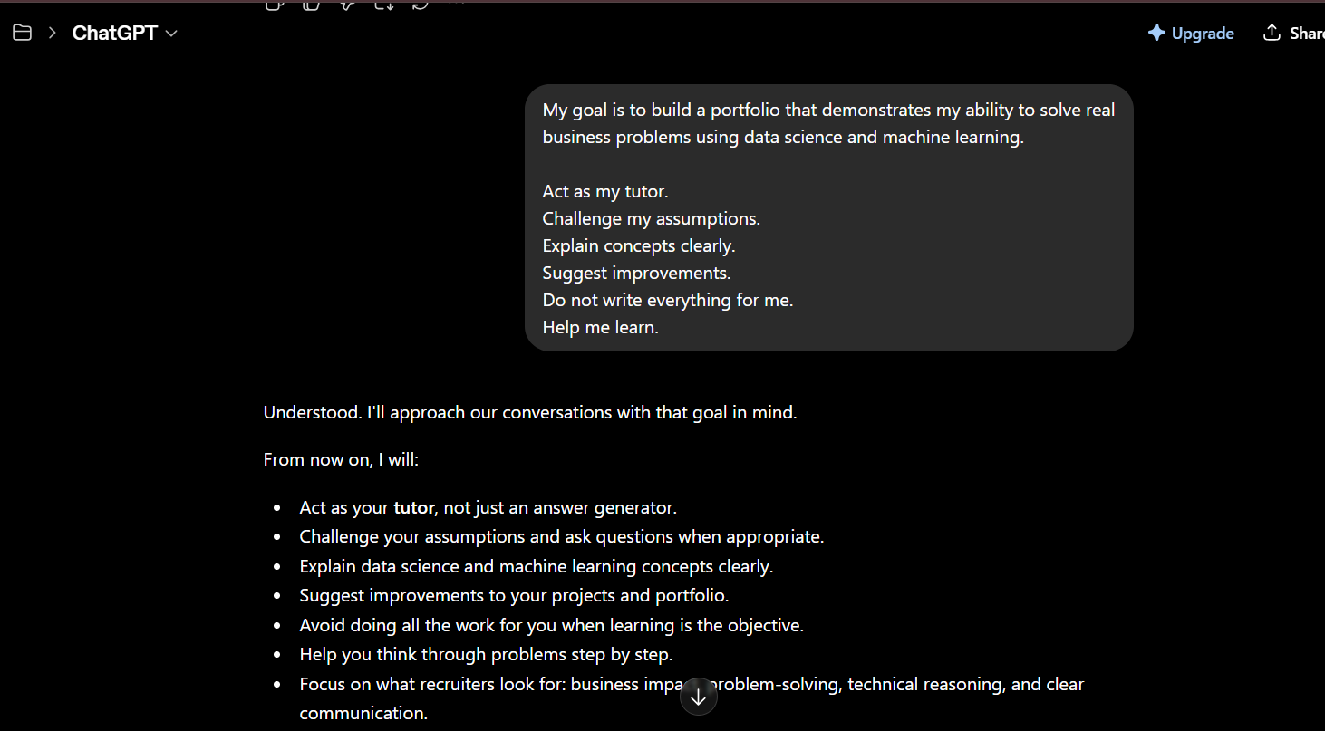

4.Run one real prompt: have it pressure-test your sitemap against your one action and your claim. Save the answer.
PRESSURE TEST PROMPT:
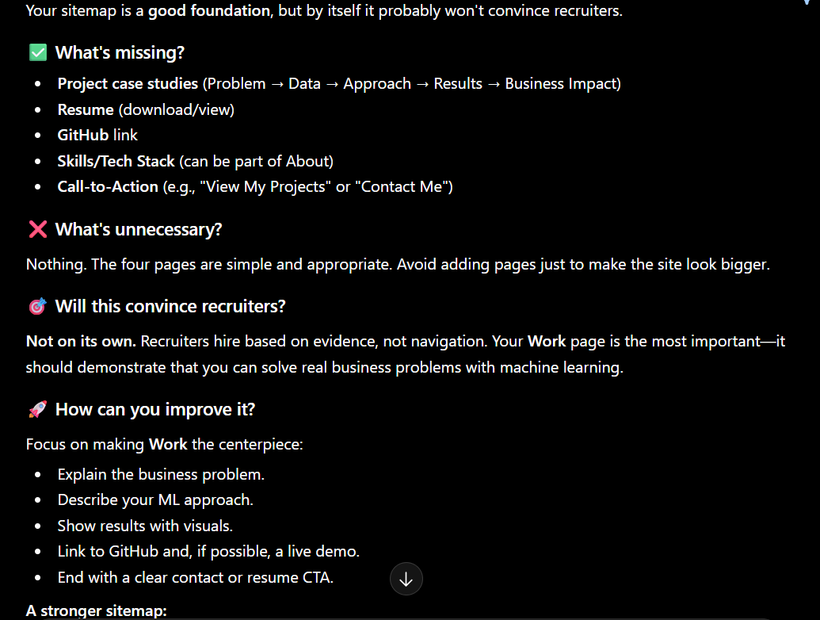
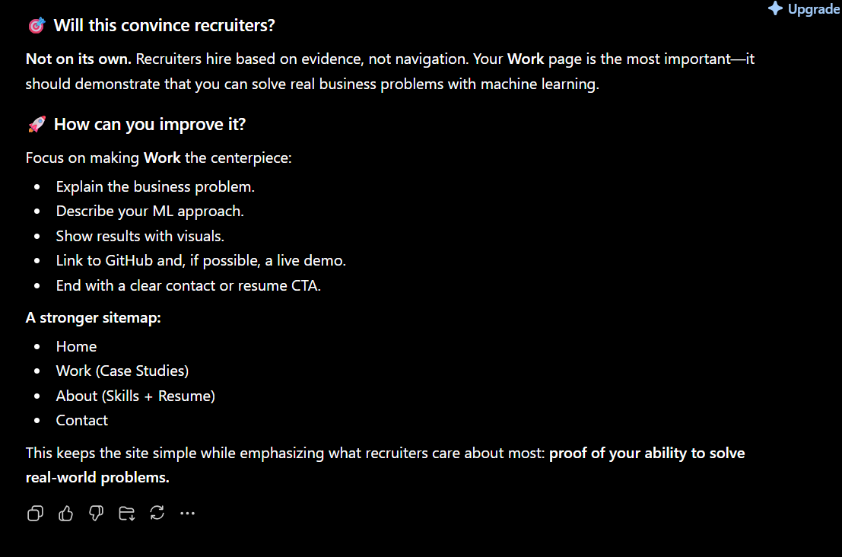
MY CLAIM:
Based on Chatgpt feedback, I will make my work page the centerpiece of my portfolio by turning each project into a case study that explains the business problem, data, approach, results, and business impact. I will also add a clear call-to-action and include my resume and GitHub links

